Super Block
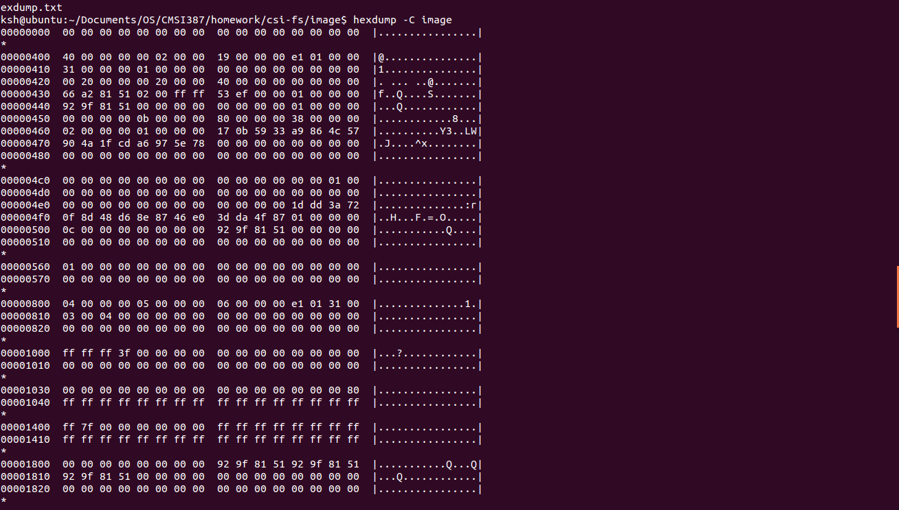

Group descriptor at 2-2
Block size = 1024 * 2 =2048
=0x800
Group Descriptor
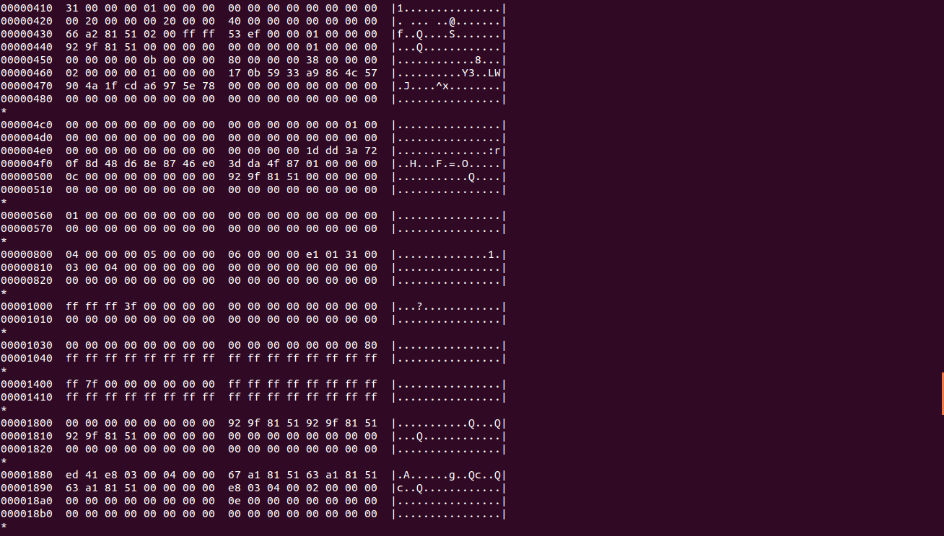

Inode Table
Inode Table
Block 0x06
Block size = 1024 * 6
= 6144
= 0x1800
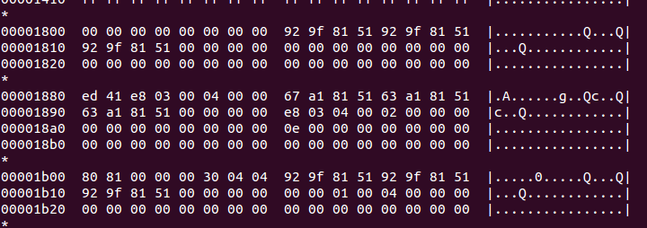

Directory
Block 0x0e
Block size = 1024 * 14
=14336
=0x3800

Directory
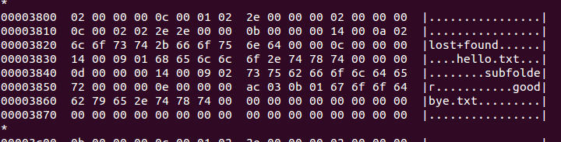
hello.txt
At inode 0x0c
= 0x1800 + (0x80 * 0x0b)
= 0x1d80
subfolder
At inode 0x0d
= 0x1800 + (0x80 * 0x0c)
= 0x1e00
goodbye.txt
At inode 0xe
= 0x1800 + (0x80 * 0x0d)
= 0x1e80

File inodes
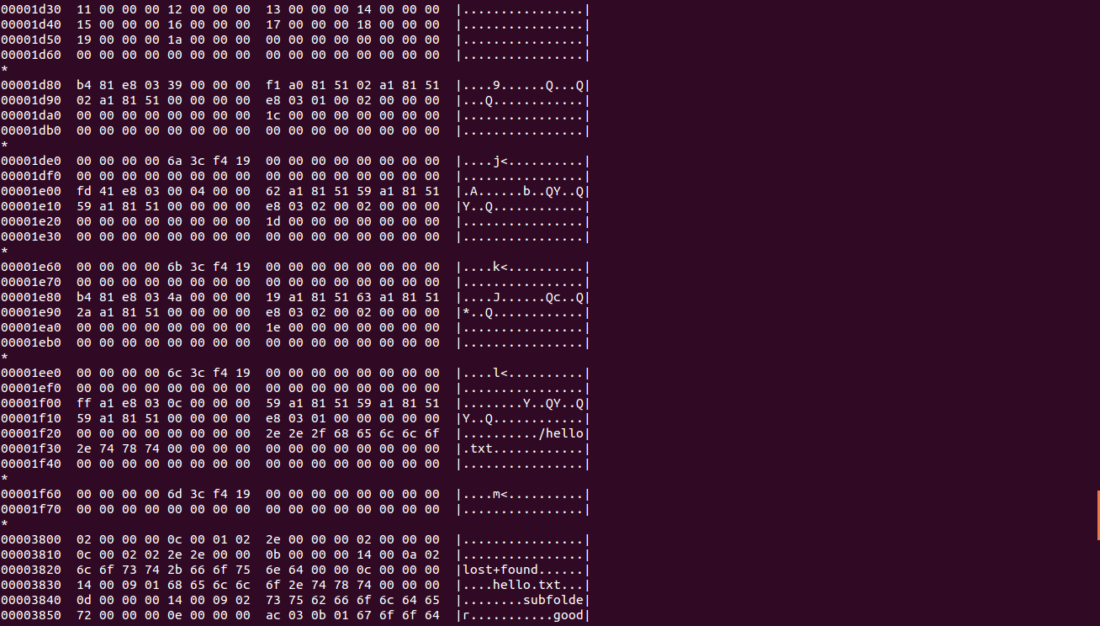
hello.txt
Data block at 0x1c
= 0x400 * 0x1c
= 0x7000
subfolder
Data block at 0x1d
= 0x400 * 0x1d
= 0x7400
goodbye.txt
Data block at 0x1e
= 0x400 * 0x1e
= 0x7800

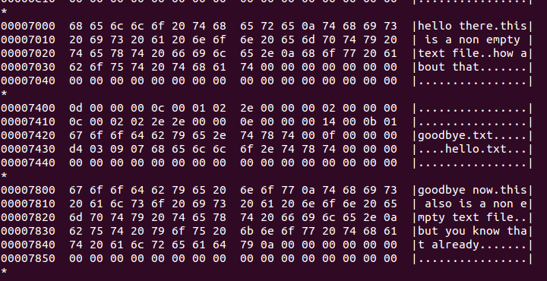
File Data

goodbye.txt
Link inode: 0x0e
=0x1e80
Data Block: 0x1e
=0x7800

hello.txt
Link inode: 0x0f
=0x1f00

hello.txt symbolic link inode
hello.txt
Encoded at inode: ../hello.txt

